
Faculty of Computer and
Data science Alexandria
University
2024 – 2025

SUBJCECT
Internet of things (IOT)

TITLE
Report assignment_3
By:
Loubid Emad Elboghdady | 23012047
Mohamed Akram Ali | 23011462
Marwan Mohamed Zain | 23011523
Yahya Mahmoud Zakaria | 23011619
Fares El Den Mohamed Saber | 23012122
Supervision:
Eng. Mohamed Hatem
Eng. Mahmoud Essam
Eng. Ahmed Salah
Eng. Fares
Q1:
IR Sensor Basics
What is the difference between an analog IR sensor and a digital IR sensor, and how does the ESP32 read signals from each type?
Analog IR Sensor:
- Continuous voltage 0–3.3V
- Can detect distance or light intensity
- Connected to an analog pin
- Read Method => analogRead()
Digital IR Sensor:
- Binary signal (HIGH = 1 or LOW = 0)
- Detects only presence or absence of object
- Connected to a digital pin
- Read Method => digitalRead()

How ESP32 Reads Each Type:
Analog IR Sensor:
- The ESP32 uses its ADC (Analog-to-Digital Converter) to read voltage levels between 0
- and 3.3V. The reading is then mapped to a value between 0 and 4095.
int value = analogRead(34);

Digital IR Sensor:
It provides a HIGH or LOW signal depending on whether an object is detected.
int value = digitalRead(25);

Q2:
ADC in ESP32
Why does the ESP32 need an Analog-to-Digital Converter (ADC) when using an IR sensor, and what does the ADC actually do?
Why ESP32 Needs ADC for IR Sensors:
- IR sensors (analog types) give a variable voltage output
- ESP32 is a digital microcontroller, and it cannot understand analog voltage directly
- So, ADC (Analog-to-Digital Converter) is used to translate analog voltage (0–3.3V) into
digital values (0–4095)

What the ADC Does:
- Converts analog voltage to a digital number
- if the input voltage is 1.65V (midway of 0–3.3V), the ADC returns ≈2048

Q3:
PWM for Servo Control
What is Pulse Width Modulation (PWM), and why is it used to control servo motor angles instead of sending a simple HIGH or LOW signal?
What is PWM (Pulse Width Modulation)?
- Duty Cycle When the signal is high, we call this "on time". To describe the amount of "on
- time" , we use the concept of duty cycle
- PWM is a technique where a digital signal is switched ON and OFF at a fast frequency
- The duration of ON time (pulse width) in each cycle determines the signal strength
Why PWM is Used for Servo Control:
PWM lets you control the angle by varying the pulse width.

Q4:
Duty Cycle Meaning
What does “duty cycle” mean in PWM, and how does changing it affect the position of a servo motor?
What is Duty Cycle?
In Pulse Width Modulation (PWM), the duty cycle represents the percentage of time a digital signal remains HIGH (on) during one complete cycle.
Formula:

$$Duty Cycle \%=\left(\frac{time signal is high }{Total period}\right)×100$$

How does it affect a servo motor?
For standard RC servo motors, the position of the servo arm is determined by the width of the HIGH pulse, not the percentage per se.
Most servo motors expect a signal every 20ms (50Hz).
  - A pulse of:
  - 1ms → moves the servo to 0°
  - 1.5ms → moves it to 90°
  - 2ms → moves it to 180°
By changing the pulse width (i.e., the duty cycle), you change the position of the servo arm.
Real-life Example: If you send a PWM signal of 5% duty cycle (1ms ON out of 20ms total), the servo will point at 0°.

Q5:
Analog vs. Digital Signals
What is the main difference between analog and digital signals, and why does an LDR or IR sensor often give analog output while a push button gives digital output?
Basis | Analog Signal | Digital Signal
Definition | Analog signals represent continuous variations in magnitude over time. | Digital signals are Discrete and quantized, with specific values.
Signal Type | Continuous waveforms | Discrete Signals
Processing | Requires complex processing for manipulation. | Easier to process and manipulate digitally.
Storage | Less efficient for storage due to continuous nature. | More efficient for storage due to discrete values.
Bandwidth | Typically requires more bandwidth. | Requires less bandwidth for transmission.
Examples | Analog audio signals, analog radio waves, Human voice, etc. | Digital audio signals, digital data streams, computers, etc.
Errors | Susceptible to noise and distortion | More resistant to noise and distortion
Circuit Component | Amplifiers, filters, continuous-wave oscillators | Microprocessors, binary counters, logic gates
Signal Values | Infinite range of values | Limited to discrete values
Conversion | No conversion required | Analog-to-digital conversion (ADC) required
Applications | Analog signals are used in electric fan, landlines, radio frequency communications, etc. | Digital signals are used in computers, smartphones, digital sensors, digital imagining, etc.

Why LDR/IR give Analog Output:
Sensors like LDRs and IR sensors measure a range of physical values (light intensity or reflected IR). These values change gradually, not in steps. The sensor converts these variations into analog voltage.
Why Push Buttons give Digital Output:
A push button has only two states: pressed or not pressed. It’s either connected to voltage (HIGH) or to ground (LOW). Therefore, it outputs a digital signal.

Q6:
LCD Communication
How does the ESP32 send data to an LCD (e.g., using I2C or parallel communication), and why is I2C often preferred?
How does ESP32 communicate with an LCD?
There are two main ways:

Parallel Communication:
  - Requires multiple GPIO pins (usually 6–10).
  - Faster data transfer.
  - Used in traditional 16x2 LCD with Hitachi HD44780 controller.
  - Code libraries: LiquidCrystal for Arduino

  - I2C Communication (Serial):
  - Uses only 2 wires: SDA (data) and SCL (clock).
  - Slower than parallel but saves GPIO pins.
  - Often involves an I2C adapter module on the LCD.
  - Code libraries: LiquidCrystal_I2C or Wire.h

Why I2C is preferred:
- Fewer pins required → ideal for ESP32 with limited GPIOs when using multiple devices.
- Easier wiring and cleaner setup.
- Supports multiple devices on the same bus using unique I2C addresses.

Real-life Example: Using I2C, you can control an LCD, an RTC clock, and a temperature sensor all using just two pins on ESP32 (GPIO 21, 22 by default).
Q7:
Debouncing Concept
When using a push button to control an LED or servo, why is “debouncing” needed, and what problem does it solve?
Debouncing is checking the push button twice in a short period of time to ensure that it is pressed. This prevents unpredictable events when checked once.
This occurs because push buttons generate spurious open/close transitions when pressed, due to mechanical and physical issues: these transitions may be read as multiple presses in a very short time fooling the program.
References:
- https://learn.sparkfun.com/tutorials/temperature-sensor-comparison/analog-vs-digital-sensor
- https://www.electronicshub.org/esp32-adc-tutorial/
- https://learn.sparkfun.com/tutorials/pulse-width-modulation
- https://learn.sparkfun.com/tutorials/hobby-servo-tutorial
- https://www.geeksforgeeks.org/physics/difference-between-analog-and-digital-signal
- https://docs.espressif.com/projects/esp-idf/en/latest/esp32/api-reference/peripherals/i2c.html
- https://docs.arduino.cc/built-in-examples/digital/Debounce/
ESP32 Project – Problem 1: Smart Door System
📌Description

Design an ESP32-based Smart Door system using a servo motor and an analog IR sensor. The door should open automatically when a person is detected and closed after a specified time or when no presence is detected.
Link on Google drive:
https://drive.google.com/drive/folders/1UxtT7bPVY_UAkSxT2O04ld_4o4d0zAPE?usp=sharing
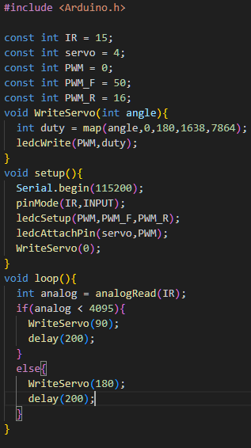

ESP32 Project – Problem 2: Keypad-Based Servo Controller
📌Description
Develop an ESP32 system to control an SG90 servo motor using a keypad interface, allowing selection of predefined angles.
Link on Google drive:
https://drive.google.com/drive/folders/1UxtT7bPVY_UAkSxT2O04ld_4o4d0zAPE?usp=sharing
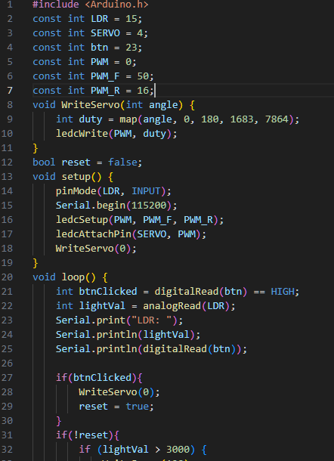

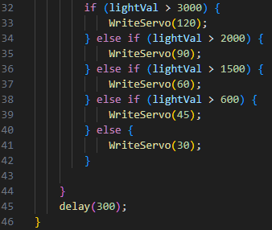

ESP32 Project – Problem 3: IR Sensor Real-Time LCD Display
📌Description Build an ESP32 project that reads analog values from an IR sensor, calculates distance, and displays both on an LCD.
Link on Google drive:
https://drive.google.com/drive/folders/1UxtT7bPVY_UAkSxT2O04ld_4o4d0zAPE?usp=sharing

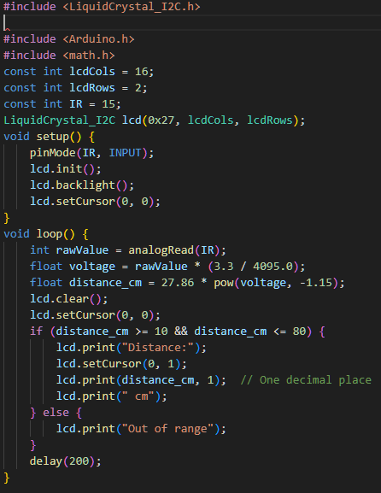

ESP32 Project – Problem 4: Light-Sensitive Alarm and Door Control
📌Description
Create an ESP32 system combining an LDR, buzzer, LED, push button, and servo motor. The system acts as a light-sensitive security door:
Link on Google drive:
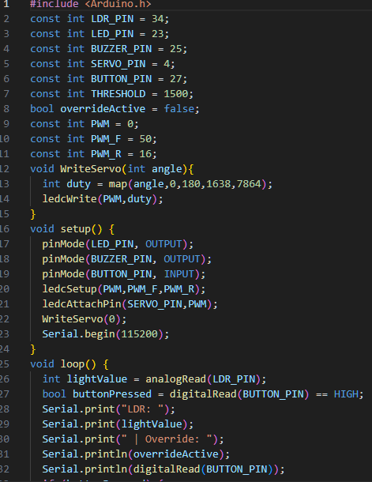
https://drive.google.com/drive/folders/1UxtT7bPVY_UAkSxT2O04ld_4o4d0zAPE?usp=sharing

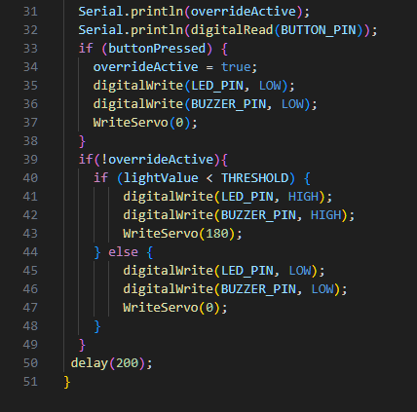

ESP32 Project – Problem 5: Intelligent Multi-Sensor Security and Environment Control System
📌 Description
Develop an ESP32-based system that integrates LDR, IR sensor, LCD, servo motor, buzzer, LED, and a push button to manage environmental monitoring and automated security actions. This project combines light-based automation, intrusion detection, and manual override control.
Link on Google drive:
https://drive.google.com/drive/folders/1UxtT7bPVY_UAkSxT2O04ld_4o4d0zAPE?usp=sharing

